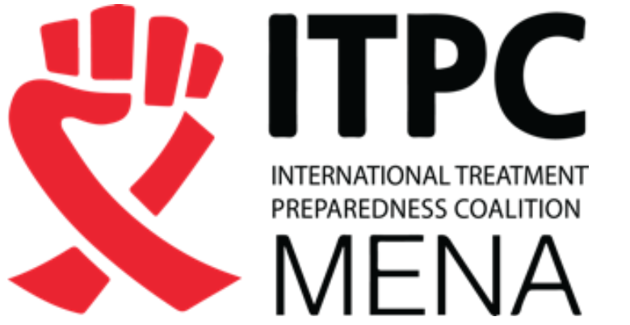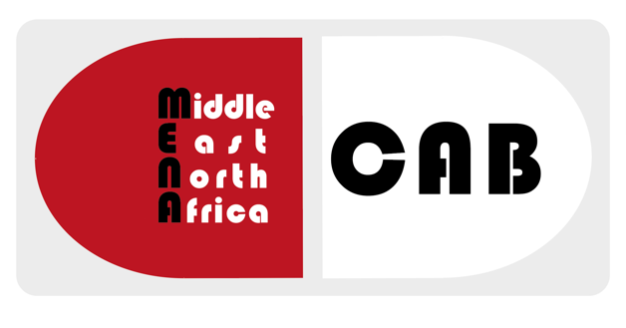

MENACAB 2017
Marrakech, Morocco
Application form

NB: Meeting dates: 3 days in mid- to end of November 2017 (to be announced), Marrakech, Morocco
Proposal reviewers will keep all information confidential.
Personal details
Name:
Title:
Organization:
Mailing Address:
Country:
E-mail address:
Phone number:
Web site (optional):
Gender:
Please answer the following questions. Text boxes expand as you type – or please delete extra space if you don't need this.
Before applying, please refer yourself to the note: “APPLICATION PROCESS note” for the Middle East and North Africa Community Advisory Board (MENACAB) Meeting

Please answer the following questions. Text boxes expand as you type – or please delete extra space if you don't need this.

Before applying, please refer yourself to the note: “Information on the APPLICATION PROCESS for the Middle East and North Africa Community Advisory Board (MENACAB) Meeting”

Deadline for applications is Monday, October 21st, 2017
Please email your completed form to: menacab.applications@gmail.com
An independent committee will review eligible applications. Notifications of successful applications will be via e-mail on October 30th, 2017

1. Why do you want to attend the HIV, HBV and HCV MENA CAB (trainings and meetings with pharmaceutical companies)?
Please also include specific skills, qualities and knowledge you wish to develop.

2. What are the strengths that you will bring to the training and meetings? Please include HIV, HBC, HCV and/or TB treatment knowledge at the regional or your national levels.

3. Please briefly describe what are main issues at stake in your country or/and at the regional level, in regards to access to diagnostics and treatments for HIV, HBV, HCV and TB (if you only work on one of these issues, please only reply on the one you work on). Please include your personal view on the situation and how it can improve effectively

4. Please describe two most important activities that you are involved in as a treatment activist/advocate
1.

2.

5. Have you ever attended a community advisory board (CAB) ?

MENACAB ? | Yes
 | No
World CAB ? | Yes
 | No
Other CAB ? | Yes
 | No
If so, what were, according to you, the strengths or weaknesses of the process?

6. Are you living with HIV, HBV, HCV and/or TB?

Yes No Prefer not to disclose Don’t know

7. How many HIV, HBV, HCV and/or TB treatment access meetings have you attended in the last 2 years?
Please comment on the meetings and how you have used the information

8. What other activities other than treatments advocacy are you involved in?
Please add details:

9. Please describe any previous experience you have had, discussing or negotiating pricing, patent, registration, or other issues with multi-national originator pharmaceutical companies, local generic producers and/or public health institutions?
Please add details:

10. What would encourage you to participate more in the HIV/HBV/HCV/TB treatment access movement in your country?
Please share whatever ideas you may have regarding the content, format, accessibility, or any other component of the forum and/or meetings.

11. Is there anything else you want to tell us about yourself and why you want to come on this meeting?

12. Supporting information
Please outline any other qualities, qualifications, skills and/or experiences you could bring to the MENA CAB meeting.

13. Do you have any conflict of interests with pharmaceutical companies or the generic industry to declare ?
Yes

No

Declaration

I confirm that the information given is true.

Signed ............................................................................

Date .................

14. Please provide the names and email contacts of two (2) references with current, first-hand knowledge of your work on HIV, HBV, HCV and/or TB:
1.

2.

