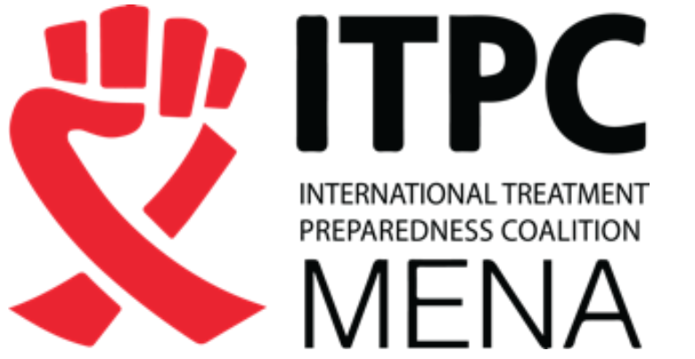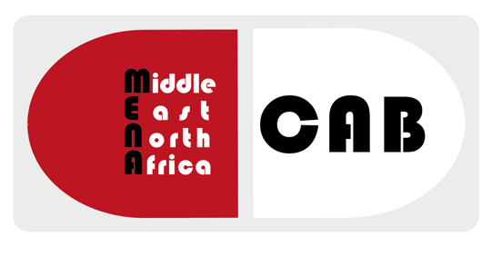

MENACAB 2017
Marrakech, Morocco
Application process

Information on the APPLICATION PROCESS for the Middle East and North Africa Community Advisory Board (MENACAB) Meeting -- A MENA countries HIV, HBV, HCV, TB Treatment Access Advocacy Training Workshop and Industry Meeting

KEY DATES:
Application submission opening: October 10th, 2017
Application submission deadline: October 21st, 2017
Notifications of successful applications: October 30th, 2017
MENACAB meeting dates: 3 days mid to late November 2017 (to be announced), Marrakech, Morocco

What is the MENACAB?
The MENACAB is a treatment advocate network which main aim is to improve access to strategic information for people living with HIV, Hepatitis B, hepatitis C and tuberculosis to equip them for effective advocacy for Universal Access at country and the regional level. In addition, one of the goals of the MENACAB is to develop and strengthen the network of treatment advocates and to provide expert training on current treatment issues and opportunities to meet with pharmaceutical companies and public health institutions, and any relevant body dealing with access issues.

What is the MENACAB 2017’s Marrakech meeting?
A forum to provide peer-driven HIV, HBV, HCV and tuberculosis advocacy treatments strategy capacity building for 20 leading advocates from Middle East and North Africa. Through training and direct meetings with originator pharmaceutical companies, generic producers, public health institutions, advocates will have the opportunity to effectively engage with companies on HIV, HBV, HCV and TB diagnostics and treatment pricing, patents, and registration issues.

Criteria to select the applicants to the MENACAB amongst the received applications:
- Person living and working in a country of the Middle East and North Africa region
- Person living with HIV, HCV, HBV, TB or key population
- Skills on intellectual property
- Skills on drug pipeline for HIV, HCV, HBV and/or TB
- Topics of the CAB in direct link to national strategies
- Previous participation to a CAB
- Cover letter and recommendation
- No conflict of interest with the pharmaceutical industry

Application submission process:

1.Complete the application form either in English or French (incomplete forms will not be considered)
In the body of the email to which your application will be attached, please provide the name, title, and e-mail address of two people who are willing to act as your reference.

2. Submit signed, completed form by scanning and e-mailing it to: menacab.applications@gmail.com

Meeting organizers:

International Treatment Preparedness Coalition in Middle East and North Africa (ITPC-MENA)

